Nolan Meeks and John Hunt

https://swe432-textbook-app.herokuapp.com

**1. Fitt’s Law**

Currently in our app, all of the buttons and controls are the same size and shape, as well as always thrown either at the top of our page, or the bottom, and usually right next to another button, as seen in the picture below. Currently these sizes are relatively small, so because of that size and positioning, Fitt’s law points out our app could be more efficient if those buttons were either along the edge of the screen, or if they were larger and closer to the cursor like a context menu.

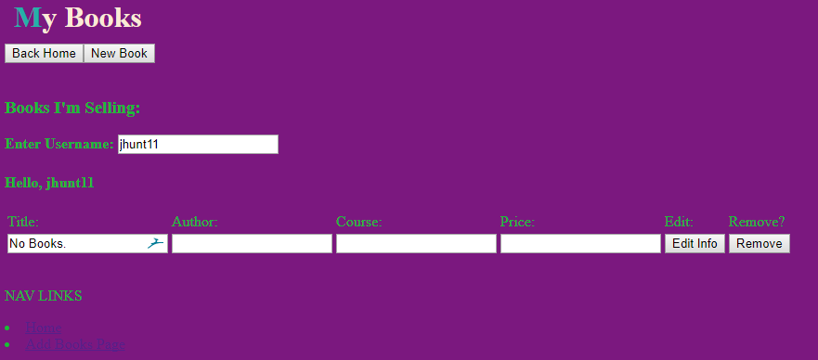

**2. Design for Flexibility and Efficiency**

Sometimes users might go about a task in a new way the designer didn’t intend for, or users might simply want several options for going about a certain task. Currently, if a user wants to add a new book, they push the button to add a new book, and are shown a page that has fields for adding a new book in addition to a solo isbn field, for if they already know the exact isbn of the book they want to add. While this is still giving users some options, a better way to design for better efficiency would be to make it so that when a user pushes a new book button, it will immediately ask if they know the ISBN, and if so they can type it in and be done, and if not, they will be presented with the default fields. This is helpful because it will limit confusion to the user compared to when all possible fields were thrown on one page.

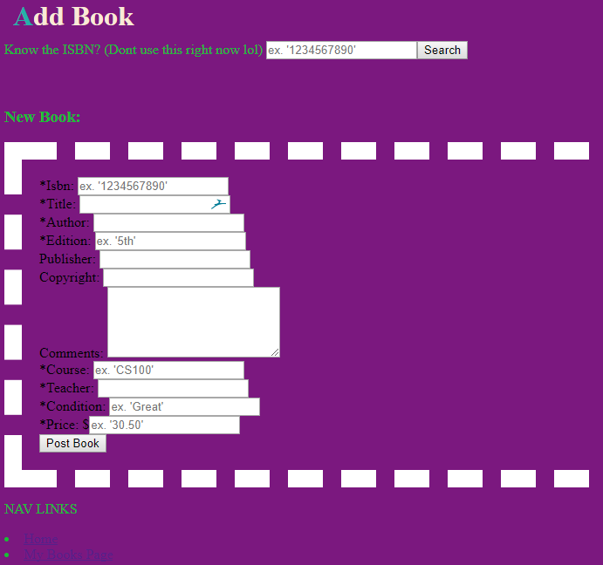

**3. Clear System Task Model**

An app with a clear system task model helps users understand the general concepts of what the app does, and help users understand a set of tasks that can be used to accomplish the app goal. It also points out that long tasks should be able to be broken up into smaller parts. In our app, on the home screen we tried to make it simple to first pickup by giving users two options, for the two main routes a user would take based off of being a buyer or a seller, however it’s still very vague and doesn’t actually let users know what they will be doing or where they’re headed towards with each direction until they’ve already clicked on it.



**4. Effective Planning**

For an app to have effective planning, it should try to help users figure out the best way to complete their task at hand, as well as keeping the user aware of their progress, and preventing them from accidentally exiting out early. Currently, when adding a new book there is nothing preventing users from filling out part of the form, and then accidentally hitting the home or “my books” button and losing it all, which violates this principle.



**5.**

**6.**

**7.**

**8.**

**Revisions**

**1. Fitt’s Law**

I modified a lot of the CSS in our app to change the way most of the buttons inside appear, with both size, shape, and behavior when mousing over the buttons. These changes provide a little bit more clarity alone just with some color-coordination, and the increase in size and padding will result in users less likely to accidently click on the wrong button, and make it faster for the user to move their cursor to the button.

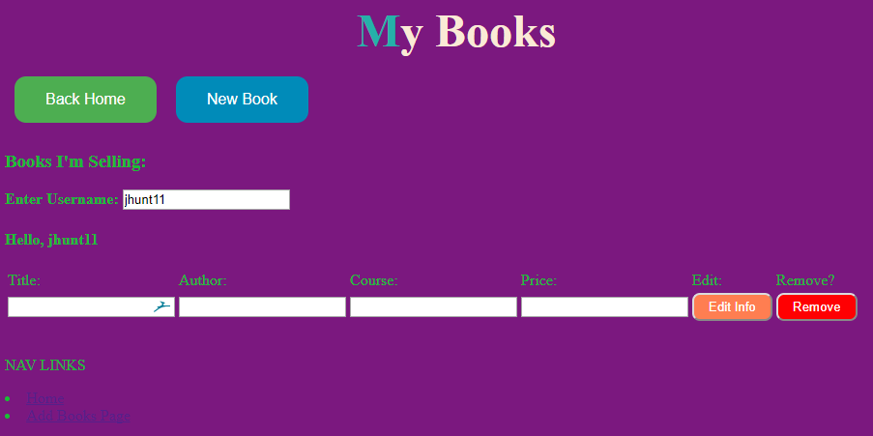

**2.**

**3. Effective Planning**

I added in the functionality of our app warning users before they navigate to a different page when creating a new textbook post. Currently, until a user fills out all the required fields, they will not be able to use the post book button, which is as it should be. The two navigation links below however are always available to click on. Similarly with the post button, until the user has successfully properly filled out the form, they will be given a warning question, just to double check if they meant to click on the navigation link before submitting.

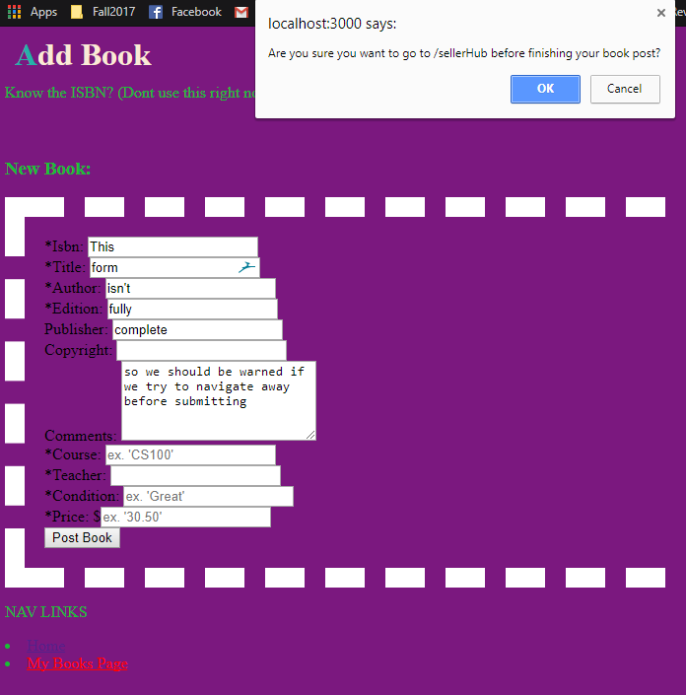

**4.**

**5.**

**6.**